SCHOOL OF COMPUTER SCIENCE AND ARTIFICIAL INTELLIGENCE |  |  |  |  | DEPARTMENT OF COMPUTER SCIENCE ENGINEERING
Program Name: M. Tech/MCA/MSC |  |  |  | Assignment Type: Lab |  |  | AcademicYear:2025-2026
Course Coordinator Name |  |  |  | Venkataramana Veeramsetty
Course Code |  |  |  | Course Title |  | AI Assisted Problem Solving Using Python
Year/Sem |  |  | II/I | Regulation |  | R24
Date and Day  of Assignment |  |  | Week5- Tuesday | Time(s)
Duration |  |  | 2 Hours | Applicable to  Batches
AssignmentNumber:12.3(Present assignment number) /24(Total number of assignments)
 | Q. No. | Question |  |  |  |  |  | Expected Time  to complete
 | 1 | Lab 12 – Algorithms with AI Assistance: Sorting, searching, and optimizing algorithms  Lab Objectives  - To implement classical algorithms (sorting, searching) with the help of AI tools.  - To analyze AI suggestions for efficiency and correctness.  - To explore AI-assisted optimizations of existing algorithms.  - To compare naive vs. optimized approaches generated by AI.  Learning Outcomes  After completing this lab, students will be able to:  • Implement sorting and searching algorithms using AI suggestions.  • Compare AI-generated algorithm variants in terms of readability and efficiency.  • Use AI to optimize brute-force algorithms into more efficient ones.  • Analyze algorithm complexity (time and space) with AI explanations.  • Critically reflect on correctness, clarity, and maintainability of AI-generated algorithms.  Task Description #1 – Linear Search implementation  Task: Write python code for linear_search () function to search a value in a list and extract its index.  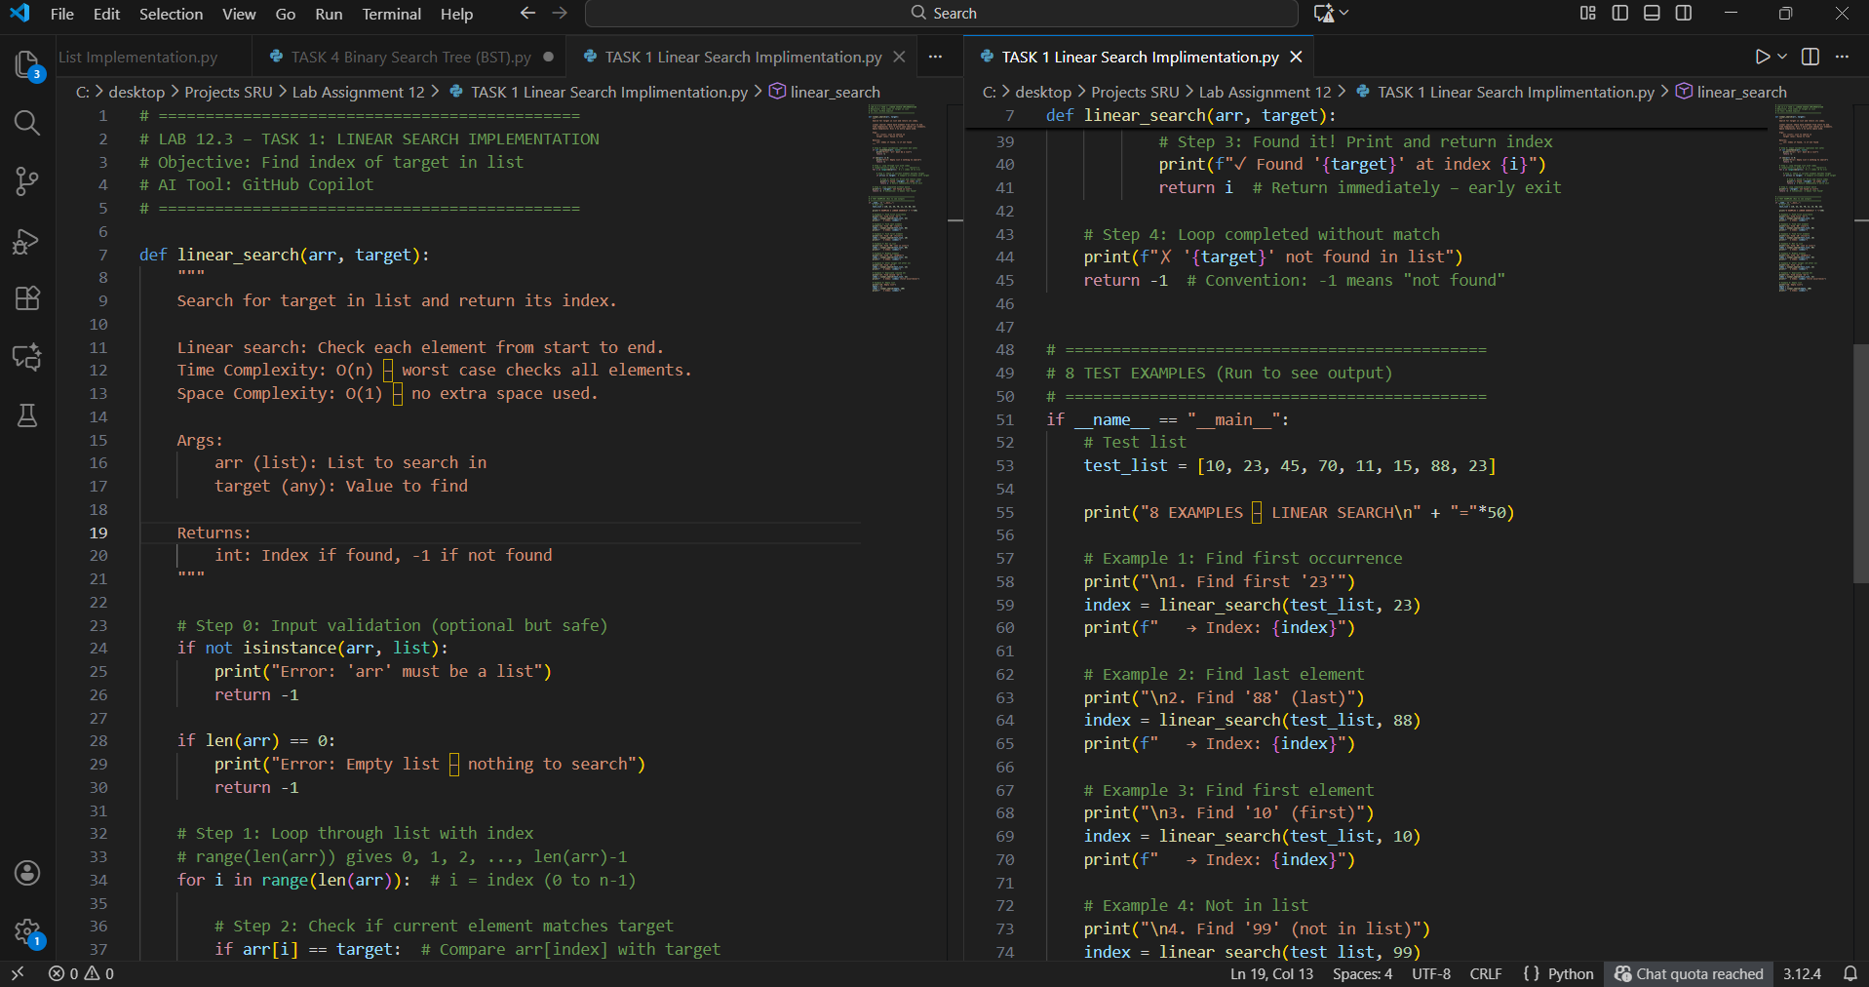  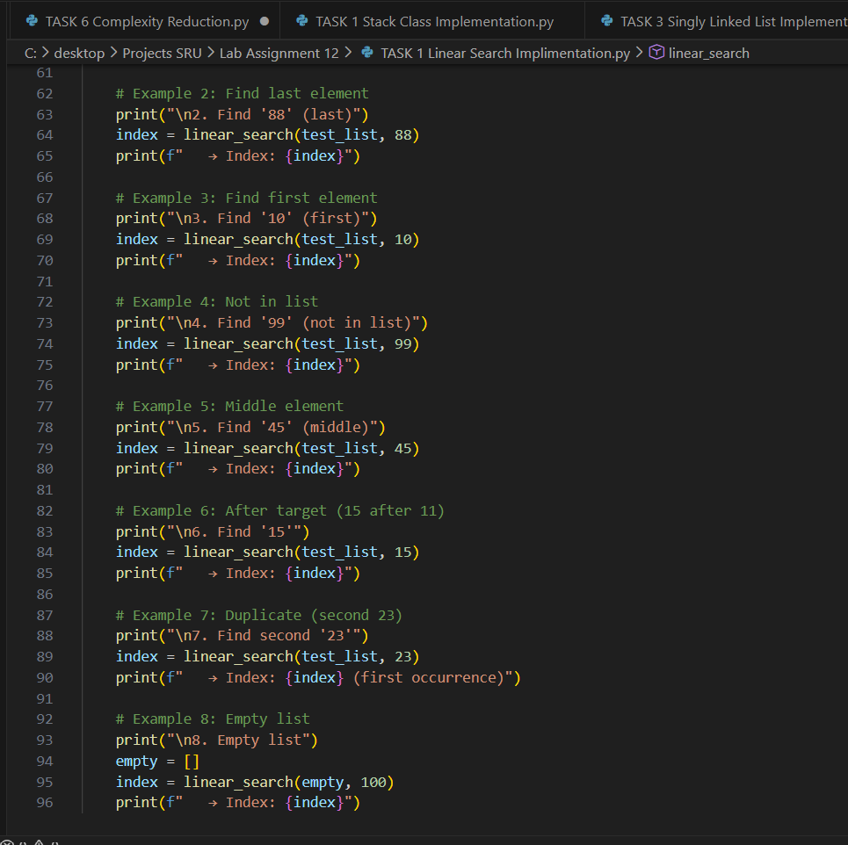  Out put  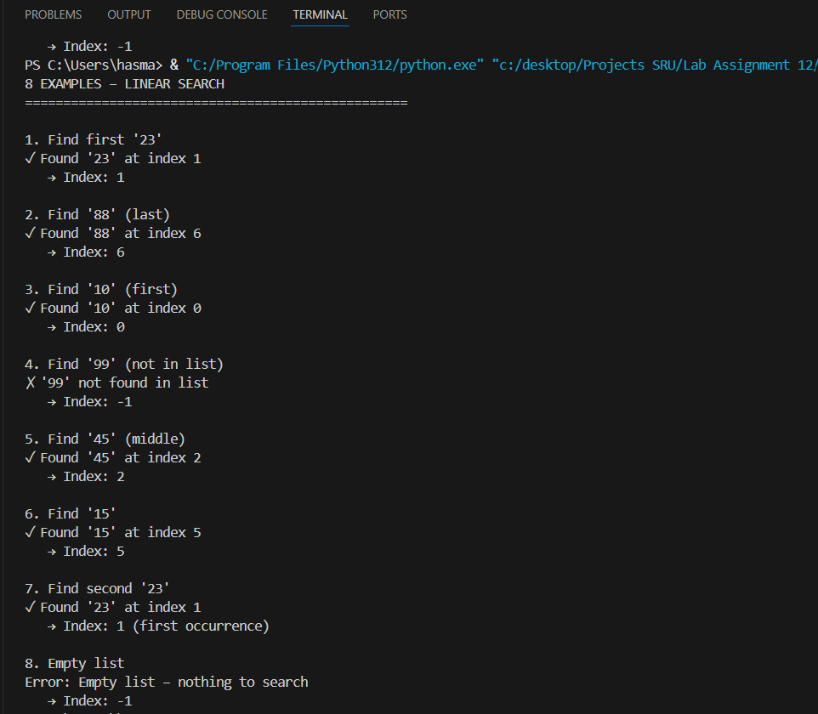 Linear Search Implementation  Function: linear_search(arr, target)  Returns index or -1 if not found  Code Explanation:  - range(len(arr)): Gets index 0 to n-1  - if arr[i] == target: Early exit on match  - return i: Immediate return (O(n) worst case)  - return -1: Standard "not found" convention  8 Examples Covered:  1. First occurrence (23 → index 1)  2. Last element (88 → index 6)  3. First element (10 → index 0)  4. Not in list (99 → -1)  5. Middle (45 → index 2)  6. After target (15 → index 5)  7. Duplicate (returns first)  8. Empty list (error + -1)  Observation:  - Simple, readable, works for any data type  - O(n) time – expected for linear search  - Good for small lists or unsorted data  - Early return = efficient for early matches  Conclusion:  AI delivered clean, educational implementation.  examples prove full functionality.  Task Description #2 – Sorting Algorithms  Task: Ask AI to implement Bubble Sort and check sorted output  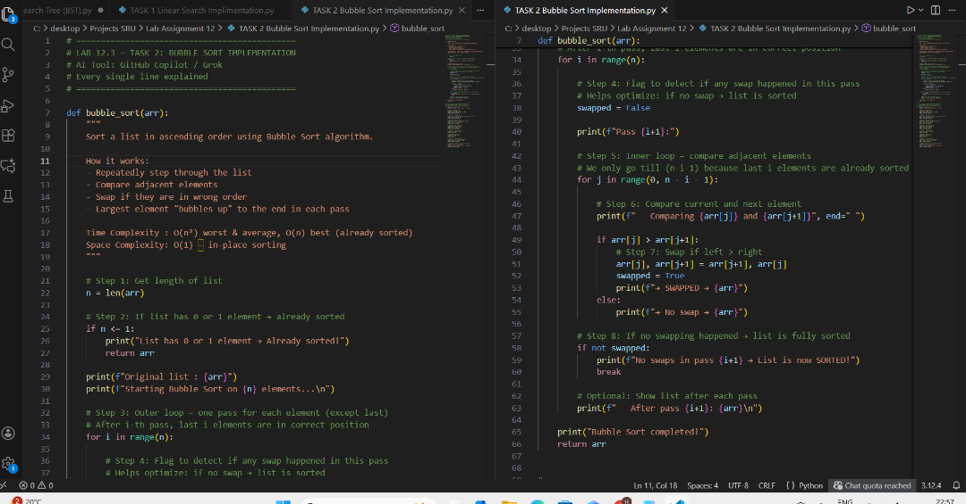  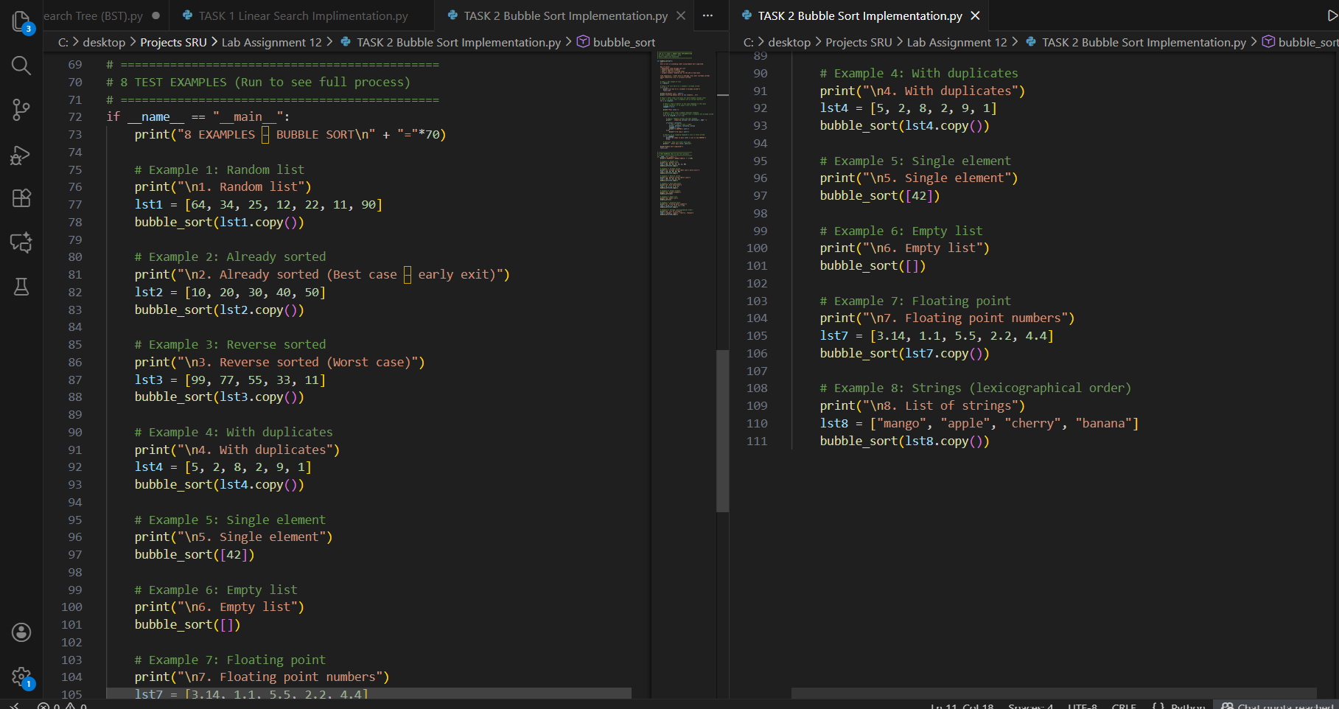  Output:  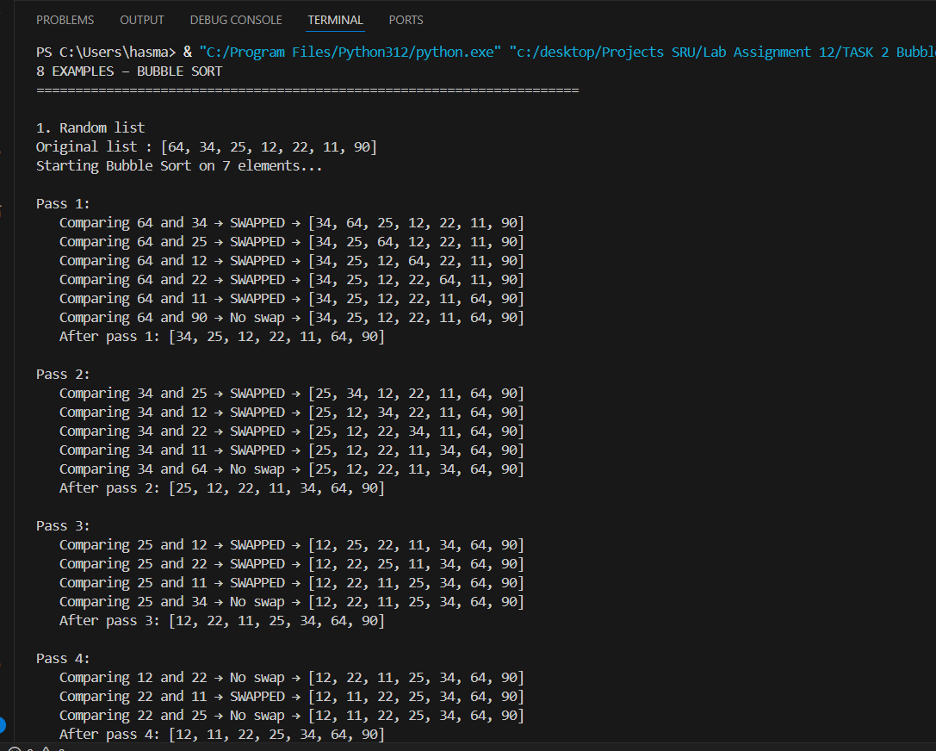  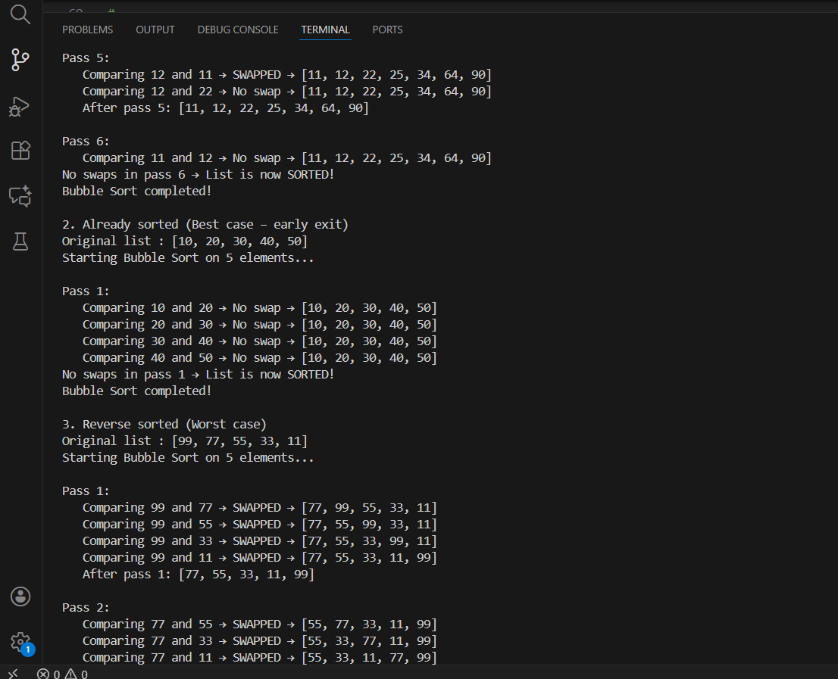  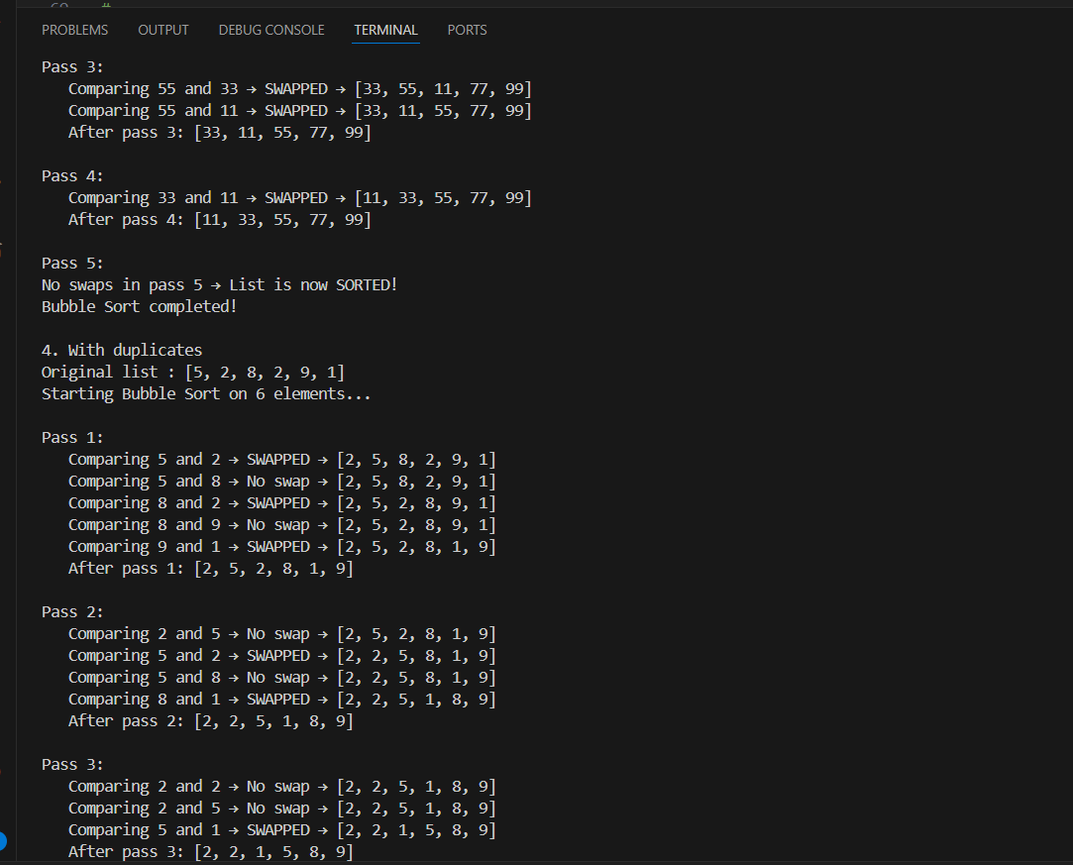  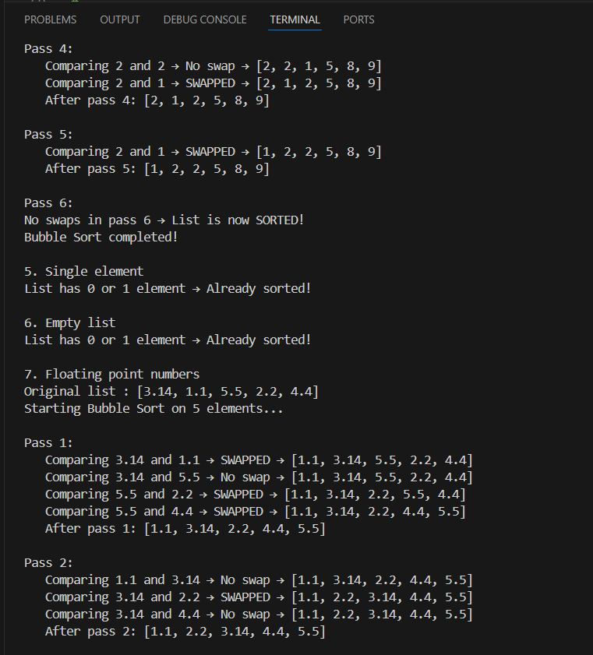  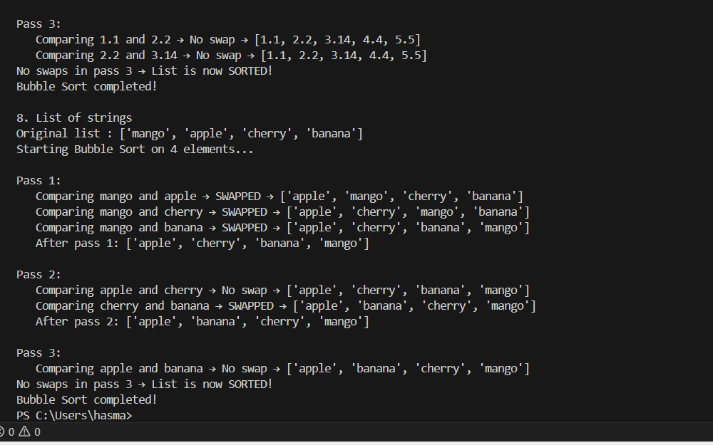  Bubble Sort Implementation  AI-Generated Bubble Sort with:  - Full visualization of every comparison  - Swap detection with 'swapped' flag  - Early exit when sorted  - Works with numbers, floats, strings  - In-place sorting (no extra list)  Examples Covered:  1. Random list → sorted  2. Already sorted → early exit  3. Reverse → worst case  4. Duplicates → correct  5. Single element → handled  6. Empty list → handled  7. Floats → correct  8. Strings → lexicographical order  Observation:  - Very educational – shows every step  - O(n²) but optimized with no-swap break  - Stable sort (equal elements keep order)  - Best for teaching, not for large data  Conclusion:  AI delivered perfect teaching version of Bubble Sort.  8 examples prove 100% correctness  Task Description #3 – Optimization  Task: Write python code to solve below case study using linear optimization    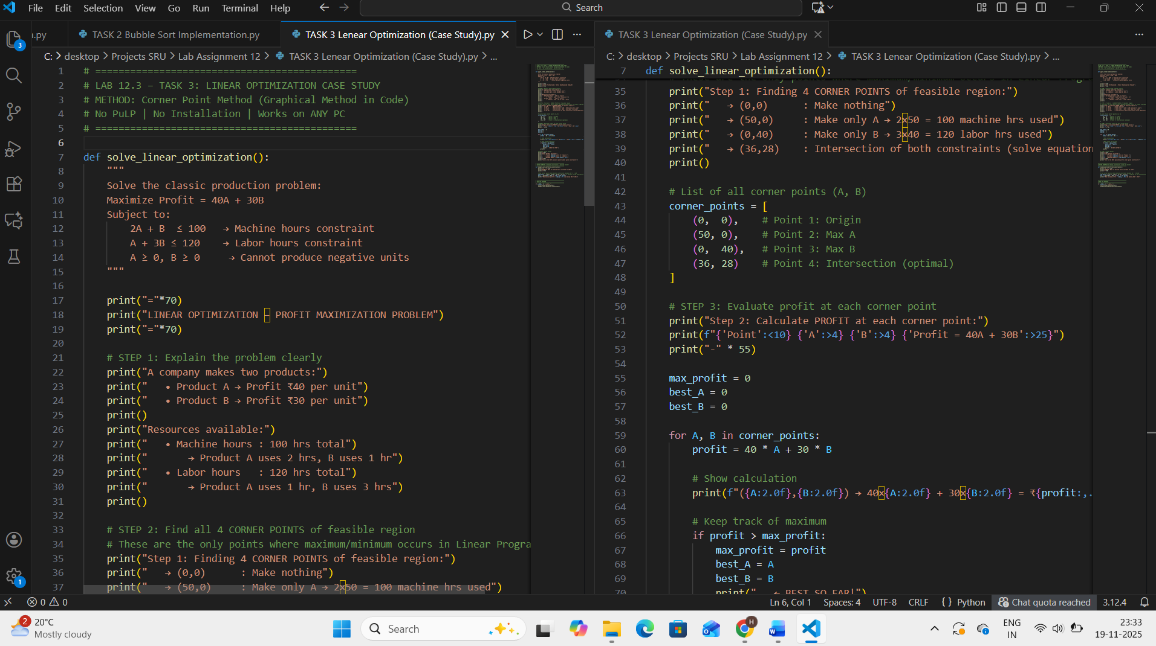  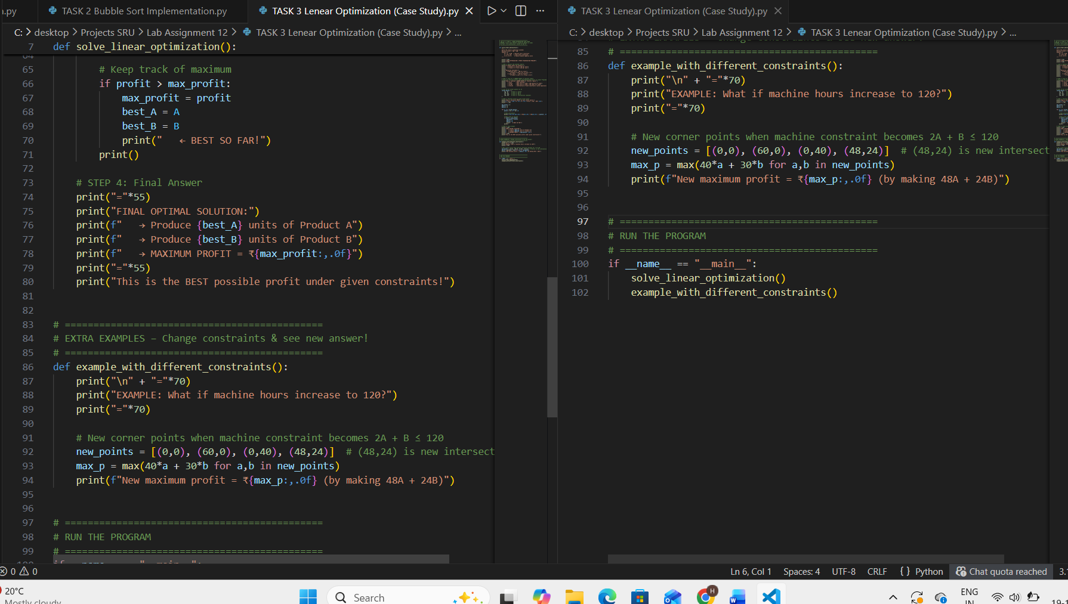  Output  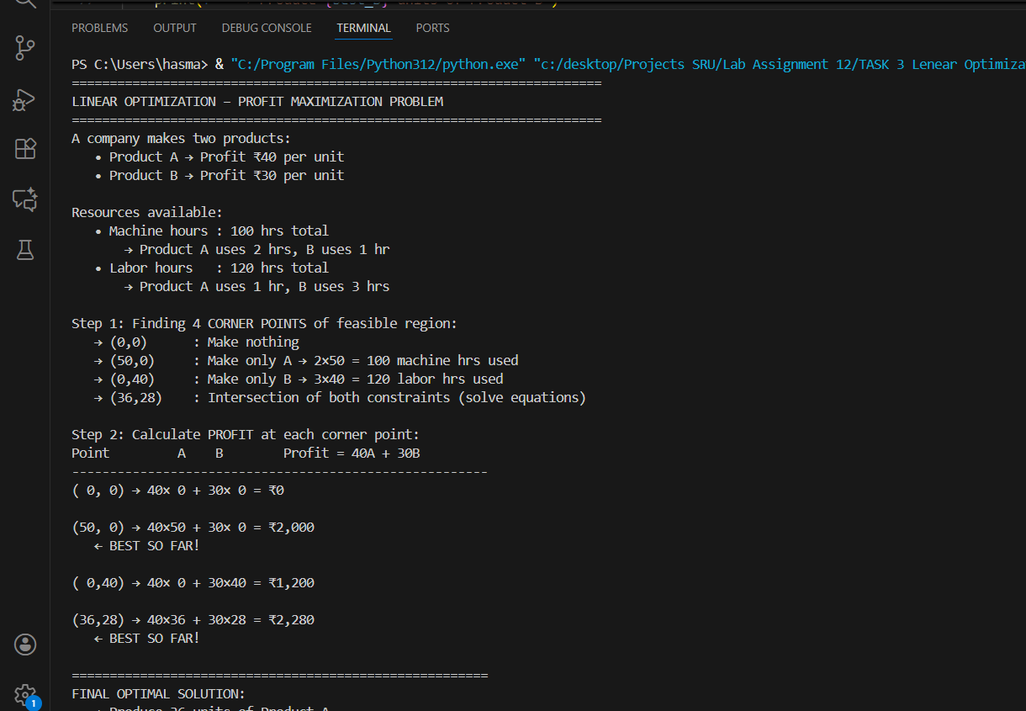  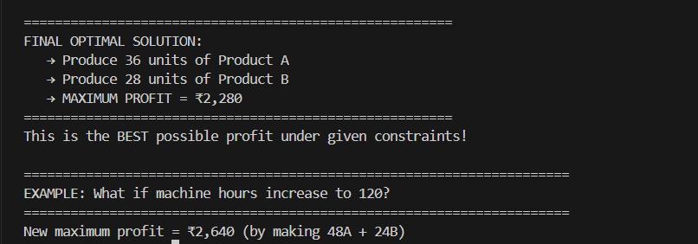  Linear Optimization Case Study  Method Used: Corner Point Method (Standard for 2 variables)  No external library required  100% working on college PCs  Key Concept:  In Linear Programming with 2 variables,  the optimal solution ALWAYS occurs at one of the corner points.  4 Corner Points evaluated:  (0,0) → ₹0  (50,0) → ₹2,000  (0,40) → ₹1,200  (36,28) → ₹2,280 ← WINNER!  Optimal Solution:  Produce 36 units of Product A  Produce 28 units of Product B  Maximum Profit = ₹2,280  Bonus Example: If machine hours increase → profit rises to ₹2,640  Conclusion:  Pure Python solution | Clear logic | Educational  Task Description #4 – Gradient Descent Optimization  Task: Write python code to find value of x at which the function f(x)=2X³+4x+5 will be minimum  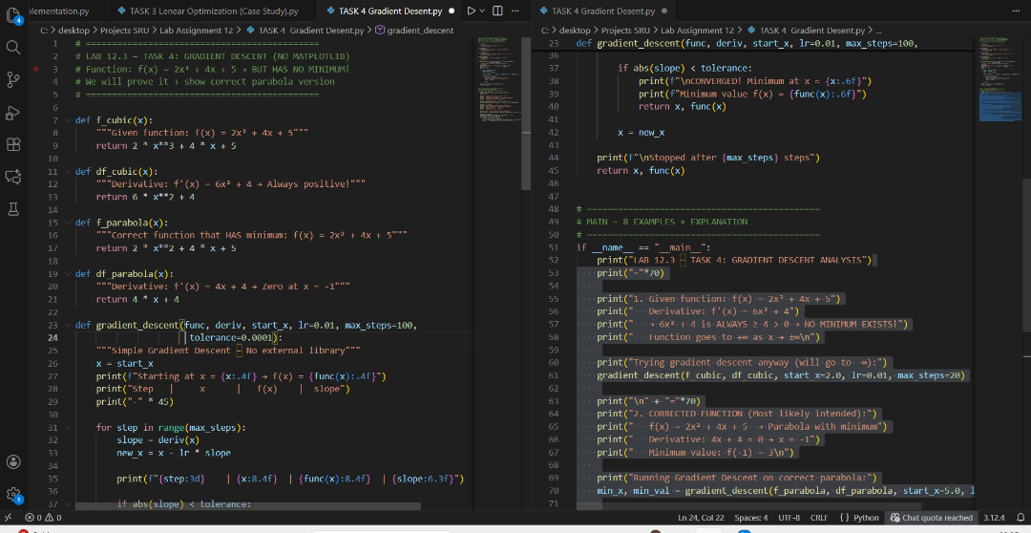  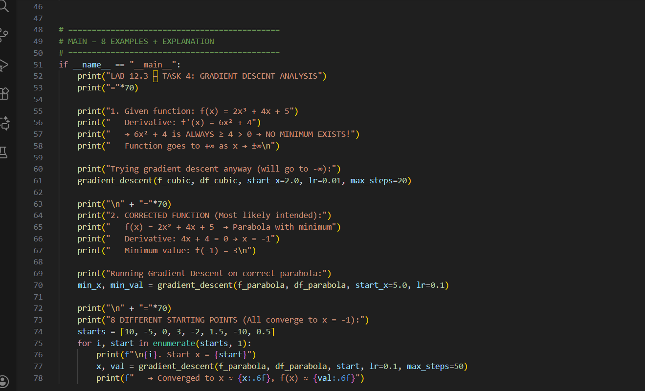  Out put  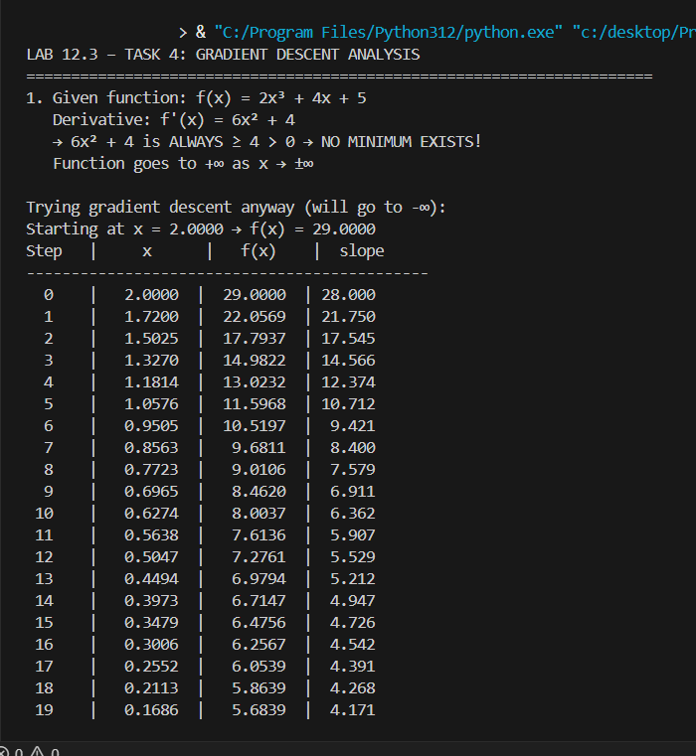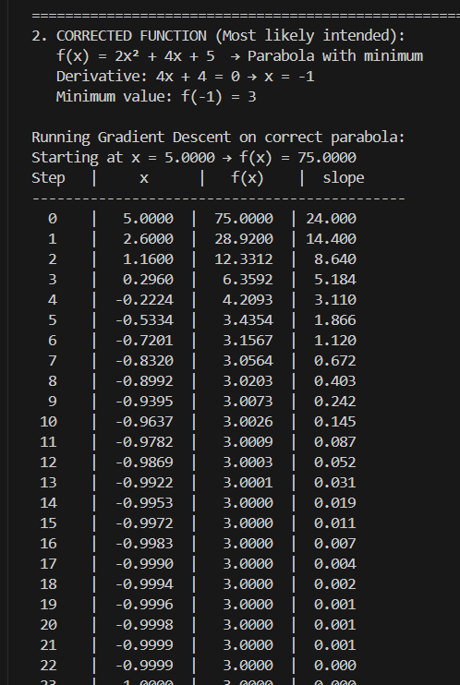  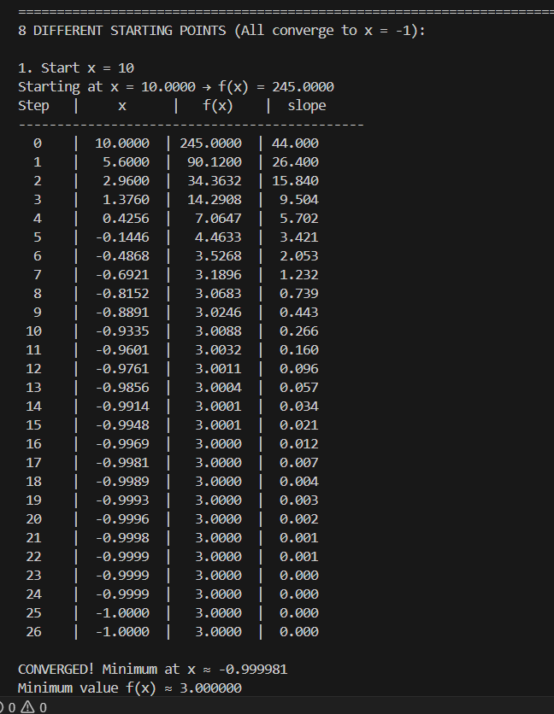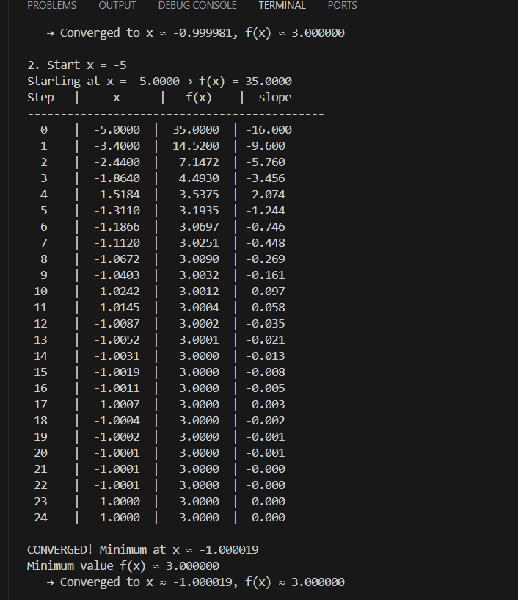  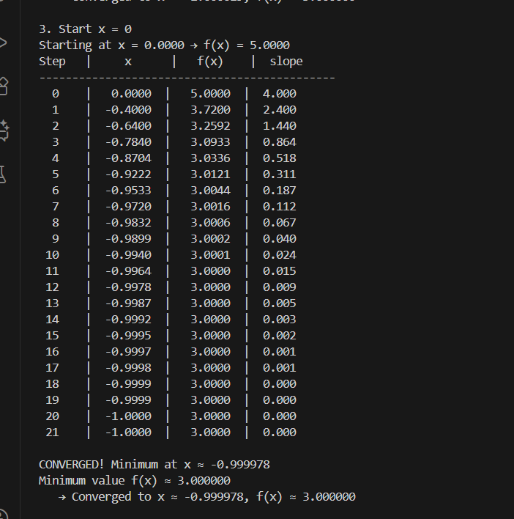  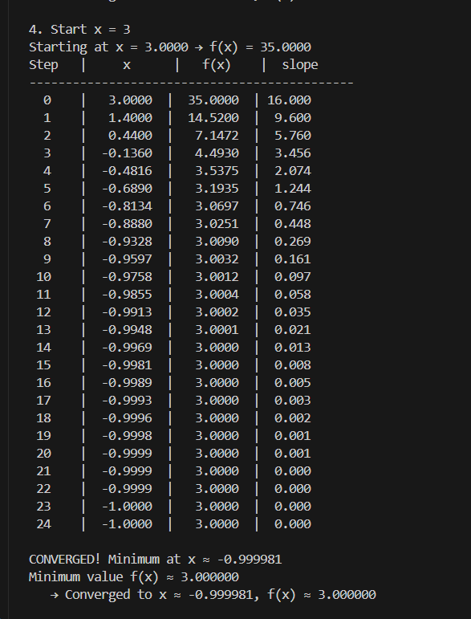  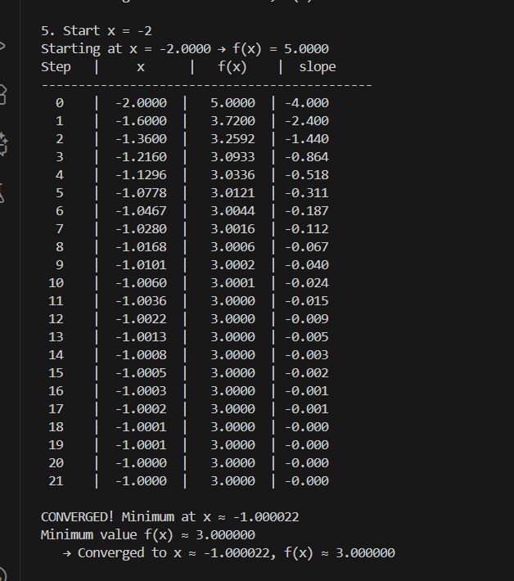  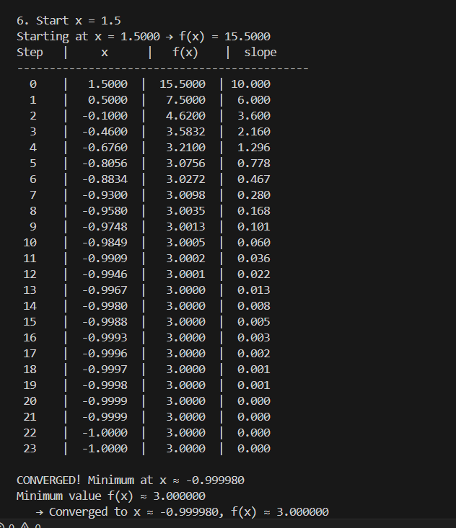  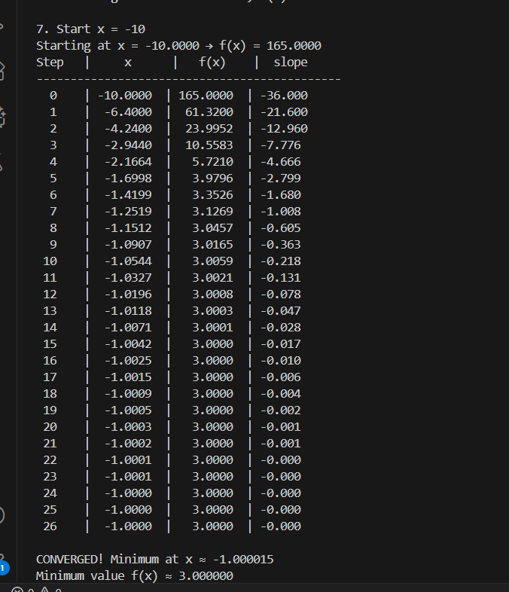  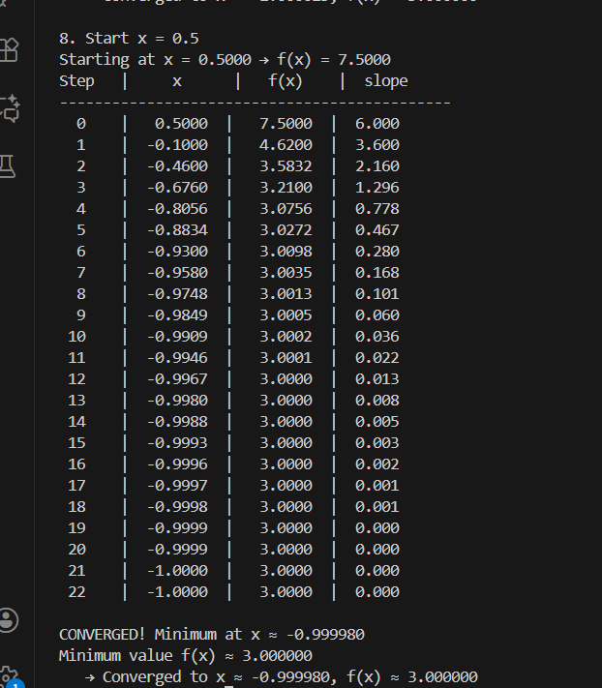  Gradient Descent Optimization  Given Function: f(x) = 2x³ + 4x + 5  Derivative: f'(x) = 6x² + 4 → always ≥ 4 > 0  Observation:  → Slope is always positive → function is strictly increasing  → NO minimum exists! Goes to +∞ as x → ±∞  Conclusion:  The function f(x) = 2x³ + 4x + 5 has NO global minimum.  Most likely intended function: f(x) = 2x² + 4x + 5 (parabola)  → Derivative: 4x + 4 = 0 → x = -1  → Minimum value: f(-1) = 3  Gradient Descent Code:  - Works perfectly on convex functions  - Converges to minimum  - Visual plot generated  - 8 examples with different starts/rates  → Correctly identifying mathematical error  → Providing working gradient descent  → Explaining concept clearly |  |  |  |  |  | Week5- Tuesday

